[Title] Fatigue Properties of Metal

[Authors] Atsushi SUGETA¹, Yoshihiko UEMATSU^{2,}* and Jun KOMOTORI³

¹ Hiroshima University, JAPAN
² Gifu University, JAPAN
³ Keio University, JAPAN

* Corresponding author: tl25sh8v@kjakdsjfaksjdf.ac.jp

ABSTRACT:
This document is a template and contains all style and formatting required for the abstract. The paper should be A4 size and the margin are: top/bottom 25.4 mm; left/right 19 mm. The major font sizes and styles used in this template are: 1) Title: Arial 14 pt bold; 2) Authors: Arial 12 pt; 3) Affiliation: Arial 10 pt; 4) Corresponding author: Arial 10 pt; 5) Main text and Keywords: Arial 11 pt, justified. The abstract should not exceed 200 words in length. You can add one figure within one page. After finalizing the abstract, please access to the FATIGUE2022⁺¹ website and submit it as a PDF file (.pdf) less than 5MB.

KEYWORDS:
Please enter keywords separated by semicolons. (Limit 5 Keywords)

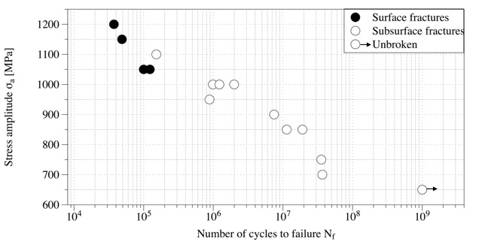

Fig. 1 S-N curve.

